**Project Report: Login and Registration System**

**Overview**

This project involves creating a user-friendly login and registration system using HTML, CSS, and JavaScript. The design focuses on an engaging and visually appealing interface that aligns with modern web design standards, while ensuring robust functionality for user authentication.

**Components**

**HTML Structure**

The HTML structure defines the layout of the login and registration forms within a responsive container. Key elements include:

* Two card components for registration and login forms.
* Forms with input fields for email, password, and password confirmation (for registration).
* Error message spans for displaying validation feedback.
* Buttons for form submission and toggling between login and registration views.

**CSS Styling**

The CSS provides a visually appealing and responsive design using:

* Bootstrap for base styling and responsive grid layout.
* Custom styles for enhanced aesthetics and interactivity.
* Linear gradients for background and card components to create a modern look.
* Smooth transitions and hover effects for better user experience.

**JavaScript Functionality**

The JavaScript code handles form validation and user interactions, including:

* Toggle functionality to switch between login and registration forms.
* Client-side form validation for email format, password length, and password confirmation.
* Asynchronous requests to the server for login and registration processes.
* Error handling and user feedback based on server responses.

**Technical Details**

**HTML**

* **Tags and Structure**: Utilizes semantic HTML5 tags (<form>, <input>, <button>) for clear structure and accessibility.
* **Bootstrap Integration**: Implements Bootstrap 4.5.2 for responsive design and grid layout.
* **Form Elements**: Includes necessary form elements with proper validation attributes (e.g., required, type="email").

**CSS**

* **Custom Styles**: Adds custom styles for cards, buttons, and form controls to enhance visual appeal.
* **Responsive Design**: Ensures the layout is responsive, providing a seamless experience across devices.
* **Hover Effects**: Implements hover effects for interactive elements to improve user experience.
* **Typography**: Utilizes Google Fonts for improved typography (Roboto).

**JavaScript**

* **Event Listeners**: Adds event listeners for form submission and toggling between forms.
* **Form Validation**: Includes functions to validate email format and password requirements.
* **Fetch API**: Uses Fetch API for making asynchronous requests to the server for login and registration.
* **User Feedback**: Displays error messages and success alerts based on validation and server responses.

**Implementation Steps**

1. **HTML Layout**:
   * Define the structure of login and registration forms.
   * Use Bootstrap classes for responsive layout.
2. **CSS Styling**:
   * Apply Bootstrap styles and add custom styles for a modern, engaging look.
   * Ensure responsive design with media queries and flexible layout techniques.
3. **JavaScript Functionality**:
   * Add event listeners for form submission and toggling between views.
   * Implement validation functions for email and password fields.
   * Use Fetch API to handle server communication for login and registration processes.
4. **Testing and Debugging**:
   * Test the forms for validation and user feedback.
   * Ensure smooth transitions and responsive design across different devices and browsers.
   * Debug and resolve any issues related to form submission and server communication.

**Web page**

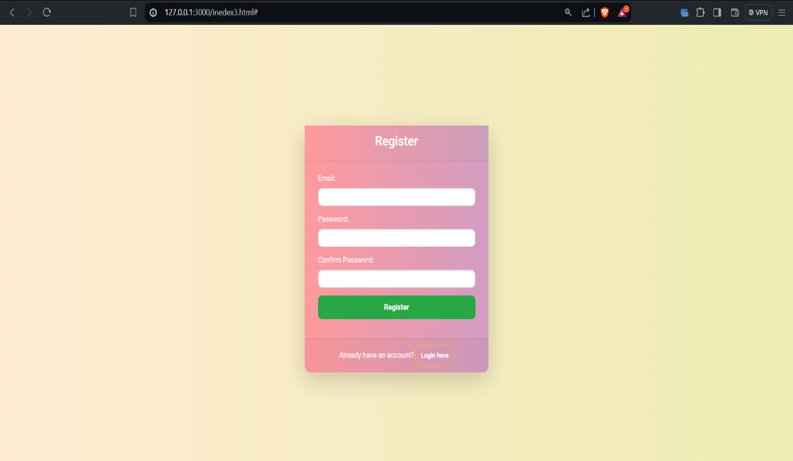

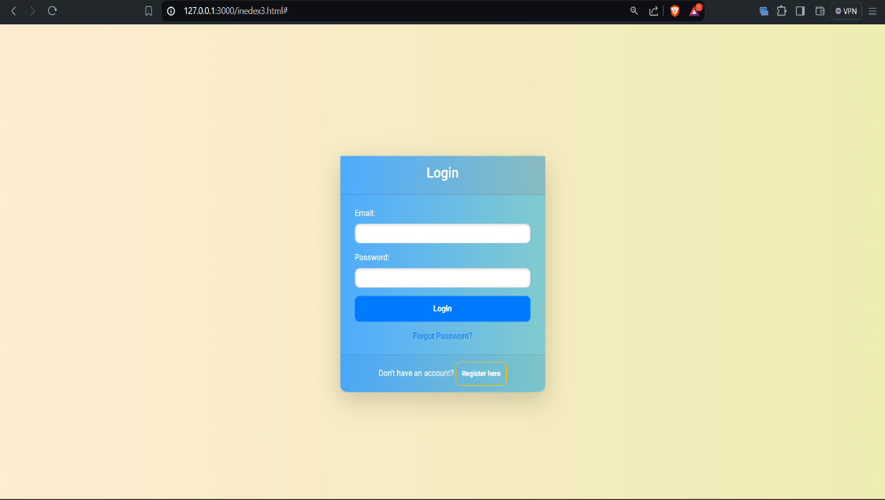

**Conclusion**

This project successfully implements a login and registration system with a focus on user experience and modern design. The use of HTML, CSS, and JavaScript ensures a robust and interactive application, providing essential functionality for user authentication with a visually appealing interface. Future improvements could include adding additional security measures, such as captcha verification and enhanced error handling, to further enhance the system's reliability and user experience.